**nopCommerce Architecture**

* This application has two servers involved
  + Application:
    - This application runs on .net core 7
    - install the application
    - If the application is horizontally scaled, then we will be using a load balancer/reverse proxy
  + Database
    - we will be using mysql database
    - This can be a managed database

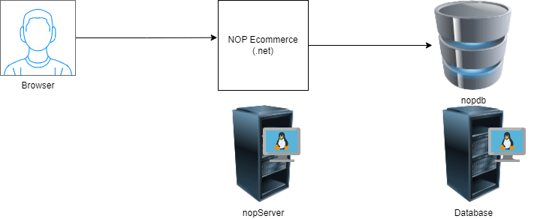

**Realizing this application in AWS**

* Let me create a free tier rds based mysql
* Install dotnet 7 on ubuntu vm <https://learn.microsoft.com/en-us/dotnet/core/install/linux-scripted-manual#scripted-install>
* <https://docs.nopcommerce.com/en/installation-and-upgrading/installing-nopcommerce/installing-on-linux.html> for installing nopcommerce on linux
* Refer to classroom video for installation

**Next Steps**

* Lets create a basic check to verify if
  + the server is alive.
  + the application is alive.
* Email Alerts: <https://mailtrap.io/> Create an inbox in mail trap